Name | Phone | Quantity | X $7 | Total Due
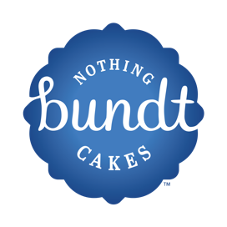
LHSGBOPC
Bundtlet Coupon Order Sheet
Order Due Date 03/13/26 Coupon Issue Date 04/01/26

Coupons can be redeemed at: Nothing Bundt Cakes 6379 Hamilton Blvd. Allentown Pa. 18106
Coupons Do Not Expire

