**Pampered Chef Online Fundraiser  
Liberty High School Grenadier Band & Orchestra Parent Club**

**Start Date**: 11/8/24 **Orders Due**: 11/25/24

***(Based on current shipping schedules from our carriers, orders received by 11/19 should arrive by Thanksgiving!)***  
~~~~~~~~~~~~~~~~~~~~~~~~~~~~~~~~~~~~~~~~~~~~~~~~  
** ALL ORDERS MUST BE PLACED USING THIS LINK:

<https://www.pamperedchef.com/party/libertyhighschool24>

To allow YOUR student to receive the credit for the order, please have all orders fill out the guest information as shown in this example:

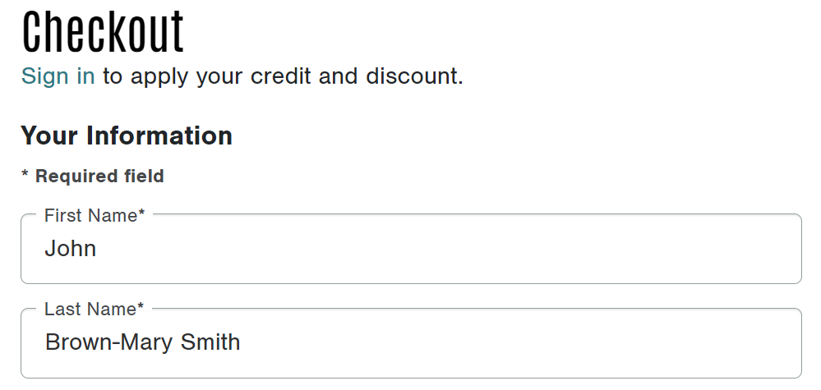

*In this example, the guest is **John Brown** and the student is **Mary Smith.**

First Name: John

Last Name: Brown-Mary Smith

* Orders will be shipped directly to the address provided
* **25% OF EACH PRODUCT** total will be credited to the student account
* Send to friends/family across the country so they can shop for themselves or for gifts for the holidays, weddings, birthdays, graduations, etc..

**\*Book your own party and receive an extra $10 to your student’s account!!**

**Questions? Please contact:**  
Linda Homer-Hurley at 610-417-6277  
Independent Kitchen Consultant with The Pampered Chef 

Good luck with your orders!